Jan Baetens and Christopher Langlois

**Nouveau Roman**

The “Nouveau Roman” or “New Novel” is used to refer to a literary and critical movement in France during the 1950s and early 1960s. Later, more experimental developments in the late 1960s and early 1970s will be labeled the “New New Novel”. Although the Nouveau Roman quickly became associated with the work of Alain Robbe-Grillet, Marguerite Duras, Nathalie Sarraute, Michel Butor, Claude Simon, and Robert Pinget, to name only the most notable, it never crystallized into so dogmatic an ideology of literature and art as had the Surrealism of André Breton during the 1920s and 1930s. To a large extent, the term “Nouveau Roman” was a fabrication of the popular press in France. The New Novelists shared however certain characteristics beyond the fact that most of their works appeared with the same publishing company, Minuit. Articles and interviews, manifestos and polemical attacks did appear in the more specialized journals of *Les Temps Modernes* and *Tel Quel*, and it is here that the aesthetic and theoretical principles of the Nouveau Roman were subjected to more nuanced critical discussion and debate than was otherwise possible in popular media outlets such as *L’Express* or *Le Monde*.

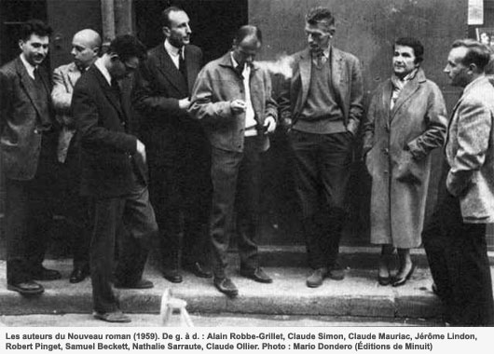

<http://www.pileface.com/sollers/IMG/jpg/pf_nouveau_roman_1959_2.jpg>

The New Novelists claimed that the French novel had missed the modernist turn in narrative, either repeating the stereotypes of the typically French tradition of the psychological novel, or obeying the ideological stances of the existentialist, communist or Christian novel, in which message clearly superseded form. The Nouveau Roman thus challenged not only the aesthetics of the novel that was dictated through the ideology of literary realism, but it also took aim at Jean-Paul Sartre’s politically-minded doctrine of “committed literature”, developed in his 1947 publication of *What is Literature?*. Insofar as the Nouveau Roman desired to distance itself from the cultural influence of the Sartrean theory of committed literature, it did so by placing an uncompromising emphasis on the formal aesthetics of the novel, which the nouveaux romanciers believed themselves to be capable of perfecting. Robbe-Grillet in particular insisted that the novelist could only be committed to literature. In the spirit of a cultural homage to Gustave Flaubert, who was perhaps the first French writer to take the genre of the novel as a serious art-form in its own right, the novelists of the Nouveau Roman similarly envisioned the novel-form as an aesthetic object that was cut off completely from the political and historical contexts that otherwise enveloped the conditions of its composition. Inspired also by the publication of Samuel Beckett’s *Molloy* and Eugene Ionesco’s *Bald Prima Donna*, both of which appeared in 1950, French novelists committed to the formal ideal of the Nouveau Roman set out to write novels that did not have to answer for or seek to transform the ethical or philosophical shortcomings of the world external to the novel.

Accordingly, the Nouveau Roman gave birth to novels that tended to be austere in their tone and that showed a disregard for the characteristic tropes of realist literature (metaphor, simile, etc.). Instead, the Nouveau Roman prized itself on adhering to strict physical descriptions of the settings and characters that animated its diverse narrative structures. In its first years, it emphasized a phenomenological approach to the real and focused on the meticulous description of objects and places, sometimes filtered through the consciousness of characters, sometimes presented in a more behaviorist style. On top of this, the Nouveau Roman also showed an unparalleled commitment to ambiguity of interpretation, disjunctive representations of space and time, and self-reflexive digressions on the complexities of literary composition. Through the theoretical writings of Jean Ricardou, who successfully launched a very idiosyncratic yet dominant reading of the group around 1970, the New Novel became known as an anti-representative way of writing, foregrounding the materiality of the verbal items at the expense of their imaginative or mimetic power and displaying the generative power of words and linguistic structures as well as the irresolvable tension between these verbal constructions and the traditional building stones of literary fiction, such as character, plot, psychology, time or space.

The Nouveau Roman, in short, dispensed with virtually all of the techniques that had hitherto assisted readers in distinguishing between reality and fiction, writer and character, and even the reader and the characters trapped, as in the case of Robbe-Grillet’s *In the Labyrinth*, within the texture of the Nouveau Roman itself. One of the lasting accomplishments of the Nouveau Roman was to successfully blur the lines between literature and theory, novelist and critic. The Nouveau Roman is viewed by many commentators as a transitional aesthetic between modernism and postmodernism.

During the 1980s, the New Novelists went back to more classic forms of narrative, often with a strong autobiographical dimension. In that, the New Novel followed the major tendencies of contemporary French prose, which turned its back to formal experiments. The later work by Claude Simon, the 1985 laureate of the Nobel Prize, exemplifies this last tendency by its personal investigation of time, memory, and archive.

**References and Further Reading**

Britton, Celia. *The Nouveau Roman: Fiction, Theory and Politics*. New York: St. Martin’s Press, 1992.

Heath, Stephen. *The Nouveau Roman: A Study in the Practice of Writing*. Philadelphia: Temple University Press, 1972.

Jefferson, Ann. *The Nouveau Roman and the Poetics of Fiction*. New York: Cambridge University Press, 1980.

Oppenheim, Lois, Ed. *Three Decades of the French New Novel*. Urbana: University of Illinois Press, 1986.

Robbe-Grillet, Alain. *For a New Novel: Essays on Fiction*. Trans. Richard Howard. New York: Grove Press, 1965.

**List of Selected Works**

Butor, Michel. *Two Novels:* Passing Time *and* A Change of Heart. Trans. Jean Stewart. New York: Simon and Schuster, 1969.

Robbe-Grillet, Alain. *Two Novels:* In the Labyrinth *and* Jealousy. Trans. Richard Howard. New York Grove Press, 1965.

--. *Last Year at Marienbad*. Trans. Richard Howard. New York: Grove Press, 1962.

Sarraute, Nathalie. *The Planetarium: A Novel*. Trans. Maria Jolas. London: John Calder.

Simon, Claude. *The Flanders Road*. Trans. Richard Howard. London: Calder, 1985.